**Project Design Phase-II**

**TechnologyStack(Architecture&Stack)**

|  |  |
| --- | --- |
| Date | June 26,2025 |
| Team ID | LTVIP2025TMID51580 |
| ProjectName | Visualizing Housing Market Trends:An Analysis Of Sale Prices And Features Using Tableau |
| MaximumMarks | 4 Marks |

**Technical Architecture:**

The Deliverable shall include the architectural diagram as below and the information as per the table1&table2

**Reference:<https://developer.ibm.com/patterns/ai-powered-backend-system-for-order-processing-during-pandemics/>**

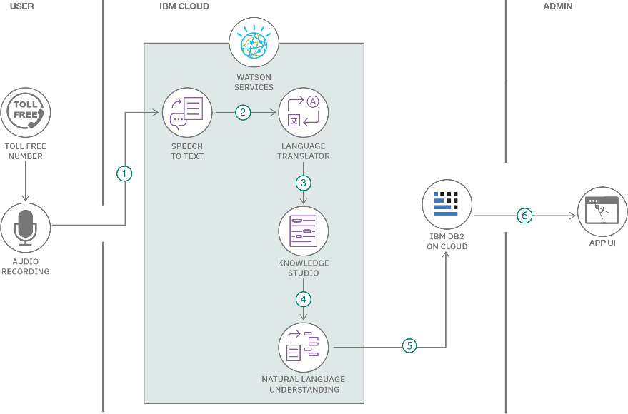

**Table-1:Components&Technologies:**

|  |  |  |  |
| --- | --- | --- | --- |
| **S.No** | **Component** | **Description** | **Technology** |
| 1. | UserInterface | Web interface for data visualization & interaction | HTML,CSS,JavaScript,Plotly.js |
| 2. | ApplicationLogic-1 | Data preprocessing and normalization | Python |
| 3. | ApplicationLogic-2 | Correlation analysis between economic index and indicators | Python(SciPy,statsmodels) |
| 4. | ApplicationLogic-3 | Interactive dashboard generation | Streamlit/Flask/Dash |
| 5. | Database | Store raw and processed data | My SQL |
| 6. | CloudDatabase | Host for shared/real-time access | Fire base |
| 7. | FileStorage | Upload and manage datasets(CSV, Excel) | Local File system |
| 8. | ExternalAPI-1 | Pull additional economic data | World Bank API, |
| 9. | ExternalAPI-2 | Geo mapping or visualization services | Google Maps API. |
| 10. | Machine Learning Model | Predict prosperity based on economic indicators | Scikit-learn Regression Model |
| 11. | Infrastructure(Server/Cloud) | Hosting and deployment | Local. |

**Table-2:ApplicationCharacteristics:**

|  |  |  |  |
| --- | --- | --- | --- |
| **S.No** | **Characteristics** | **Description** | **Technology** |
| 1. | Open-SourceFrameworks | Frame works used for visualization and app deployment | Streamlit,Plotly,Dash,Pandas |
| 2. | SecurityImplementations | Basic input validation,role access,and secure upload | SSL,SHA-256hashing,Firebase Auth |
| 3. | Scalable Architecture | Modular,scalable with cloud hosting&stateless API s | Micro services architecture on Flask/Streamlit |
| 4. | Availability | Cloud-hosted with minimal downtime | AWSEC2,FirebaseHosting,Streamlit Cloud |
| 5. | Performance | Optimized through caching and minimal pay load visualization for fast loading | JSONqueries |

**References:**

**<https://c4model.com/>**

**[https://developer.ibm.com/patterns/online-order-processing-system-duringpandemic](https://developer.ibm.com/patterns/online-order-processing-system-during-pandemic/)[/https://www.ibm.com/cloud/architecture](https://www.ibm.com/cloud/architecture) <https://aws.amazon.com/architecture>**

**<https://medium.com/the-internal-startup/how-to-draw-useful-technical-architecture-diagrams-2d20c9fda90d>**